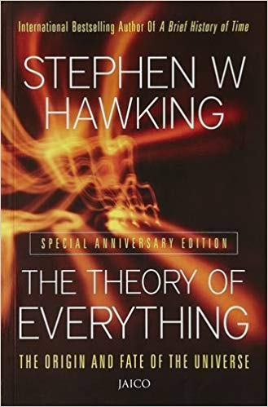

The Theory of Everything: The Origin and Fate of the Universe

By Stephen W. Hawking

Based on a series of lectures given at Cambridge University, Professor Hawking's work introduced "the history of ideas about the universe" as well as today's most important scientific theories about time, space, and the cosmos in a clear, easy-to-understand way.